Final Software Package Proposal

Lane Dorscher
3/8/2026
CIS309-T302 Data and Information Management (2263-1)
Jack Li

Introduction
Bob’s Home Repairs is a small business that provides residential repair services. Currently, Bob manages customers, bids, repairs, materials, and payments manually using memory and paper records. This approach limits efficiency, increases the chance of error, and prevents the business from scaling.
This report proposes a relational database design to computerize the most burdensome business processes, including customer management, project tracking, bidding, repair execution, material usage, supplier relationships, and payment tracking. The proposed design follows relational database best practices and is structured to support future growth while remaining aligned with Bob’s current business rules.

Identified Entities and Attributes
CUSTOMER
Stores customer contact and billing information.
- CUSTOMER_ID (PK) – INT
- CUSTOMER_F_NAME – VARCHAR(30)
- CUSTOMER_M_NAME – VARCHAR(30)
- CUSTOMER_L_NAME – VARCHAR(30)
- CUSTOMER_STREET_ADDRESS – VARCHAR(150)
- CUSTOMER_CITY – VARCHAR(50)
- CUSTOMER_STATE – VARCHAR(30)
- CUSTOMER_ZIP_CODE – VARCHAR(14)
- CUSTOMER_PHONE – VARCHAR(12)
PROJECT
Represents a specific repair job or engagement for a customer.
- PROJECT_ID (PK) – INT
- CUSTOMER_ID (FK) – INT
- PROJECT_STREET_ADDRESS – VARCHAR(150)
- PROJECT_CITY – VARCHAR(50)
- PROJECT_STATE – VARCHAR(30)
- PROJECT_ZIP_CODE – VARCHAR(14)
- PROJECT_START_DATE – DATETIME
- PROJECT_END_DATE – DATETIME
- PROJECT_STATUS – VARCHAR(15)
BID
Represents a cost estimate provided for a project.
- BID_ID (PK) – INT
- PROJECT_ID (FK) – INT
- BID_DATE – DATETIME
- BID_ESTIMATED_HOURS – INT
- BID_LABOR_RATE – FLOAT
- BID_ESTIMATED_MATERIAL_COST – FLOAT
- BID_ESTIMATED_COST – FLOAT
- BID_STATUS – VARCHAR(15)
REPAIR
Represents individual repair tasks performed under an accepted bid.
- REPAIR_ID (PK) – INT
- BID_ID (FK) – INT
- REPAIR_DESCRIPTION – VARCHAR(255)
- REPAIR_HOURS_WORKED – INT
- REPAIR_LABOR_COST – FLOAT
MATERIAL
Represents catalog-level materials purchased from suppliers.
- MATERIAL_ID (PK) – INT
- SUPPLIER_ID (FK) – INT
- MATERIAL_NAME – VARCHAR(100)
- MATERIAL_DESCRIPTION – VARCHAR(255)
- UNIT_TYPE – VARCHAR(25)
- UNIT_COST – FLOAT
REPAIR_MATERIAL
Junction table that records which materials are used in which repairs.
- MATERIAL_ID (PK, FK) – INT
- REPAIR_ID (PK, FK) – INT
- QUANTITY_USED – INT
- EXTENDED_COST – FLOAT

SUPPLIER
Represents vendors from whom Bob purchases materials.
- SUPPLIER_ID (PK) – INT
- SUPPLIER_NAME – VARCHAR(100)
- SUPPLIER_CONTACT_NAME – VARCHAR(100)
- SUPPLIER_CONTACT_PHONE – VARCHAR(12)
- SUPPLIER_CREDIT_TERM_DAYS – INT
SUPPLIER_PAYMENT
Tracks payments made by Bob to suppliers.
- SUPPLIER_PAYMENT_ID (PK) – INT
- SUPPLIER_ID (FK) – INT
- PAYMENT_DATE – DATE
- PAYMENT_AMOUNT – FLOAT
- PAYMENT_METHOD – VARCHAR(20)
CUSTOMER_PAYMENT
Tracks payments made by customers after project completion.
- CUSTOMER_PAYMENT_ID (PK) – INT
- CUSTOMER_ID (FK) – INT
- PROJECT_ID (FK) – INT
- PAYMENT_DATE – DATE
- PAYMENT_AMOUNT – FLOAT
- PAYMENT_METHOD – VARCHAR(20)

Proposed Relationships
- A Customer can have many Projects.
- A Project belongs to one and only one Customer.
- A Project can have many Bids.
- A Bid belongs to one and only one Project.
- A Bid can include many Repairs.
- A Repair belongs to one and only one Bid.
- A Repair can have many Repair_Material records.
- A Repair_Material record belongs to one and only one Repair.
- A Material can appear in many Repair_Material records.
- A Repair_Material record references one and only one Material.
- A Supplier can provide many Materials.
- A Material is provided by one and only one Supplier.
- A Supplier can receive many Supplier Payments.
- A Supplier Payment belongs to one and only one Supplier.
- A Customer can make many Customer Payments.
- A Customer Payment belongs to one and only one Customer.
- A Project can have many Customer Payments.
- A Customer Payment may be applied to one Project.

Entity-Relationship-Diagram

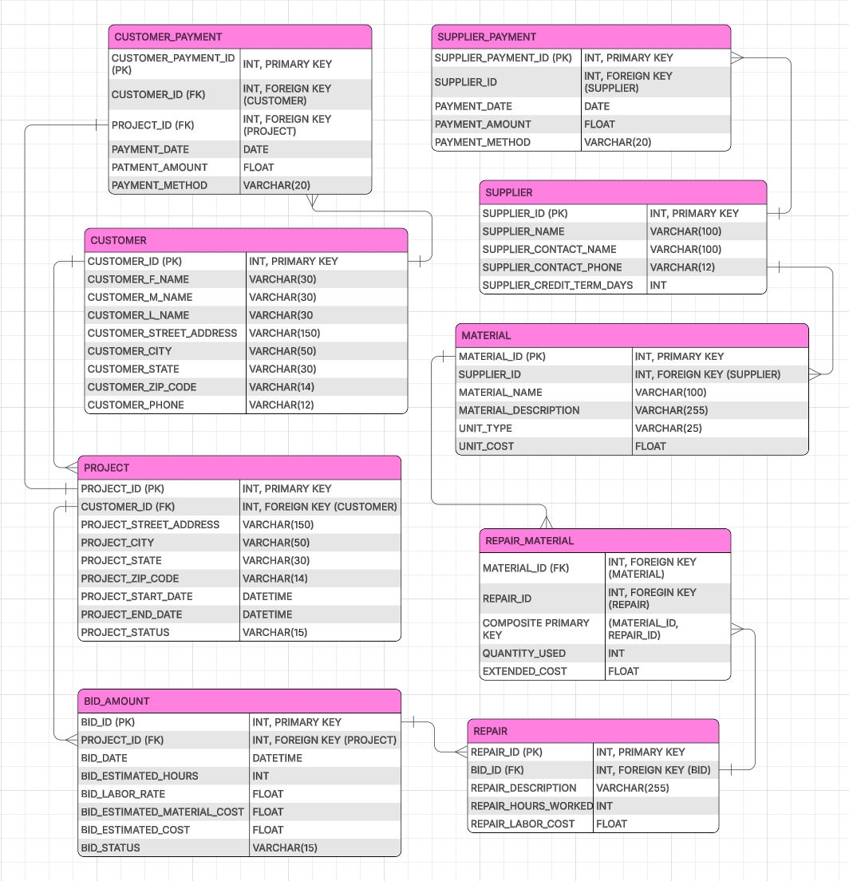

Design’s Intentions
The idea behind this design dictates that data redundancy will be reduced and the material definitions will be separated from their usage within a repair. This will also track whether a customer has multiple ongoing projects and whether the business has placed a bid on them. Multiple bids are allowed to be placed in effort to counter or keep track of outstanding bids on projects. Finally, this allows for flexible payment tracking ensuring that each project or repair has great references to which project has received payments. Utilizing this structure will provide a solid foundation for growth and maintain accurate reporting with the use of queries.

Create Table Queries

CUSTOMER
CREATE TABLE CUSTOMER (
CUSTOMER_ID INT PRIMARY KEY,
CUSTOMER_F_NAME VARCHAR(30),
CUSTOMER_M_NAME VARCHAR(30),
CUSTOMER_L_NAME VARCHAR(30),
CUSTOMER_STREET_ADDRESS VARCHAR(150),
CUSTOMER_CITY VARCHAR(50),
CUSTOMER_STATE VARCHAR(30),
CUSTOMER_ZIP_CODE VARCHAR(14),
CUSTOMER_PHONE VARCHAR(12)
);

SUPPLIER
CREATE TABLE SUPPLIER (
SUPPLIER_ID INT PRIMARY KEY,
SUPPLIER_NAME VARCHAR(100),
SUPPLIER_CONTACT_NAME VARCHAR(100),
SUPPLIER_CONTACT_PHONE VARCHAR(12),
SUPPLIER_CREDIT_TERM_DAYS INT
);

PROJECT
CREATE TABLE PROJECT (
PROJECT_ID INT PRIMARY KEY,
CUSTOMER_ID INT,
PROJECT_STREET_ADDRESS VARCHAR(150),
PROJECT_CITY VARCHAR(50),
PROJECT_STATE VARCHAR(30),
PROJECT_ZIP_CODE VARCHAR(14),
PROJECT_START_DATE DATETIME,
PROJECT_END_DATE DATETIME,
PROJECT_STATUS VARCHAR(15),
FOREIGN KEY (CUSTOMER_ID) REFERENCES CUSTOMER(CUSTOMER_ID)
);

BID
CREATE TABLE BID (
BID_ID INT PRIMARY KEY,
PROJECT_ID INT,
BID_DATE DATETIME,
BID_ESTIMATED_HOURS INT,
BID_LABOR_RATE FLOAT,
BID_ESTIMATED_MATERIAL_COST FLOAT,
BID_ESTIMATED_COST FLOAT,
BID_STATUS VARCHAR(15),
FOREIGN KEY (PROJECT_ID) REFERENCES PROJECT(PROJECT_ID)
);

REPAIR
CREATE TABLE REPAIR (
REPAIR_ID INT PRIMARY KEY,
BID_ID INT,
REPAIR_DESCRIPTION VARCHAR(255),
REPAIR_HOURS_WORKED INT,
REPAIR_LABOR_COST FLOAT,
FOREIGN KEY (BID_ID) REFERENCES BID(BID_ID)
);

MATERIAL
CREATE TABLE MATERIAL (
MATERIAL_ID INT PRIMARY KEY,
SUPPLIER_ID INT,
MATERIAL_NAME VARCHAR(100),
MATERIAL_DESCRIPTION VARCHAR(255),
UNIT_TYPE VARCHAR(25),
UNIT_COST FLOAT,
FOREIGN KEY (SUPPLIER_ID) REFERENCES SUPPLIER(SUPPLIER_ID)
);

REPAIR_MATERIAL
CREATE TABLE REPAIR_MATERIAL (
MATERIAL_ID INT,
REPAIR_ID INT,
QUANTITY_USED INT,
EXTENDED_COST FLOAT,
PRIMARY KEY (MATERIAL_ID, REPAIR_ID),
FOREIGN KEY (MATERIAL_ID) REFERENCES MATERIAL(MATERIAL_ID),
FOREIGN KEY (REPAIR_ID) REFERENCES REPAIR(REPAIR_ID)
);

SUPPLIER_PAYMENT
CREATE TABLE SUPPLIER_PAYMENT (
SUPPLIER_PAYMENT_ID INT PRIMARY KEY,
SUPPLIER_ID INT,
PAYMENT_DATE DATE,
PAYMENT_AMOUNT FLOAT,
PAYMENT_METHOD VARCHAR(20),
FOREIGN KEY (SUPPLIER_ID) REFERENCES SUPPLIER(SUPPLIER_ID)
);

CUSTOMER_PAYMENT
CREATE TABLE CUSTOMER_PAYMENT (
CUSTOMER_PAYMENT_ID INT PRIMARY KEY,
CUSTOMER_ID INT,
PROJECT_ID INT,
PAYMENT_DATE DATE,
PAYMENT_AMOUNT FLOAT,
PAYMENT_METHOD VARCHAR(20),
FOREIGN KEY (CUSTOMER_ID) REFERENCES CUSTOMER(CUSTOMER_ID),
FOREIGN KEY (PROJECT_ID) REFERENCES PROJECT(PROJECT_ID)
);

Sample Data

INSERT INTO CUSTOMER VALUES
(1, 'Lane', 'M', 'Dorscher', '123 Maple Street', 'Omaha', 'NE', '68164', '4025551001'),
(2, 'Peter', NULL, 'Parker', '20 Ingram Street', 'Queens', 'NY', '11375', '2125552002'),
(3, 'John', NULL, 'Shepard', '742 Evergreen Terrace', 'Springfield', 'IL', '62701', '2175553003'),
(4, 'Garrus', NULL, 'Vakarian', '456 Oak Avenue', 'Seattle', 'WA', '98101', '2065554004'),
(5, 'Tali', NULL, 'Zorah', '789 Pine Drive', 'San Diego', 'CA', '92101', '6195555005');

INSERT INTO SUPPLIER VALUES
(1, 'Midwest Lumber Supply', 'Clark Kent', '4025556001', 30),
(2, 'Home Electrical Distributors', 'Diana Prince', '4025556002', 45),
(3, 'Precision Plumbing Supply', 'Bruce Wayne', '4025556003', 30),
(4, 'Quality Roofing Materials', 'Natasha Romanoff', '4025556004', 60),
(5, 'Interior Finish Warehouse', 'Steve Rogers', '4025556005', 30);

INSERT INTO PROJECT VALUES
(1, 1, '123 Maple Street', 'Omaha', 'NE', '68164', '2026-01-05', NULL, 'Active'),
(2, 2, '20 Ingram Street', 'Queens', 'NY', '11375', '2026-01-07', NULL, 'Active'),
(3, 3, '742 Evergreen Terrace', 'Springfield', 'IL', '62701', '2026-01-10', NULL, 'Active'),
(4, 4, '456 Oak Avenue', 'Seattle', 'WA', '98101', '2026-01-12', NULL, 'Active'),
(5, 5, '789 Pine Drive', 'San Diego', 'CA', '92101', '2026-01-15', NULL, 'Active');

INSERT INTO BID VALUES
(1, 1, '2026-01-06', 12, 75, 850, 1750, 'Approved'), -- Bathroom remodel
(2, 2, '2026-01-08', 8, 70, 500, 1060, 'Approved'), -- Roof patch
(3, 3, '2026-01-11', 10, 80, 650, 1450, 'Approved'), -- Electrical upgrade
(4, 4, '2026-01-13', 6, 65, 400, 790, 'Approved'), -- Plumbing repair
(5, 5, '2026-01-16', 14, 85, 900, 2090, 'Approved'); -- Kitchen cabinet install

INSERT INTO REPAIR VALUES
(1, 1, 'Replace bathroom vanity and plumbing fixtures', 12, 900),
(2, 2, 'Repair damaged roof shingles and seal flashing', 8, 560),
(3, 3, 'Upgrade electrical breaker panel to 200 amp', 10, 800),
(4, 4, 'Replace leaking kitchen sink drain line', 6, 390),
(5, 5, 'Install new kitchen cabinets and hardware', 14, 1190);

INSERT INTO MATERIAL VALUES
(1, 1, '2x4 Lumber', 'Standard framing lumber', 'Piece', 6.50),
(2, 2, '12 Gauge Electrical Wire', 'Copper residential wire', 'Foot', 1.25),
(3, 3, 'PVC Drain Pipe', '2 inch plumbing pipe', 'Foot', 3.75),
(4, 4, 'Architectural Roof Shingles', 'Weather resistant shingles', 'Bundle', 35.00),
(5, 5, 'Kitchen Cabinet Set', 'Preassembled cabinet units', 'Set', 750.00);

INSERT INTO REPAIR_MATERIAL VALUES
(1, 1, 15, 97.50), -- Lumber used in vanity framing
(4, 2, 5, 175.00), -- Shingles used
(2, 3, 120, 150.00), -- Electrical wire
(3, 4, 20, 75.00), -- PVC pipe
(5, 5, 1, 750.00); -- Cabinet set

INSERT INTO SUPPLIER_PAYMENT VALUES
(1, 1, '2026-01-20', 500.00, 'Credit'),
(2, 2, '2026-01-21', 300.00, 'Wire'),
(3, 3, '2026-01-22', 250.00, 'Credit'),
(4, 4, '2026-01-23', 400.00, 'Card'),
(5, 5, '2026-01-24', 750.00, 'Wire');

INSERT INTO CUSTOMER_PAYMENT VALUES
(1, 1, 1, '2026-02-05', 1750.00, 'Card'),
(2, 2, 2, '2026-02-06', 1060.00, 'Card'),
(3, 3, 3, '2026-02-07', 1450.00, 'Wire'),
(4, 4, 4, '2026-02-08', 790.00, 'Cash'),
(5, 5, 5, '2026-02-09', 2090.00, 'Wire');

Navigational SQL Queries

List the names of the customers who provided bids last month
SELECT
CUST.CUSTOMER_F_NAME,
CUST.CUSTOMER_L_NAME
FROM CUSTOMER CUST
JOIN PROJECT PROJ ON PROJ.CUSTOMER_ID = CUST.CUSTOMER_ID
JOIN BID BID ON BID.PROJECT_ID = PROJ.PROJECT_ID
WHERE
DATENAME(month, DATEADD(month, -1, GETDATE())) = DATENAME(month, BID.BID_DATE);

List all the customers that have an outstanding balance (amount due to Bob) that is greater than $500.

SELECT
CUST.CUSTOMER_F_NAME,
CUST.CUSTOMER_L_NAME,
(BID.BID_ESTIMATED_COST - ISNULL(SUM(CUST_PAY.PAYMENT_AMOUNT), 0)) AS AmountDue
FROM CUSTOMER CUST
JOIN PROJECT PROJ ON PROJ.CUSTOMER_ID = CUST.CUSTOMER_ID
JOIN BID BID ON BID.PROJECT_ID = PROJ.PROJECT_ID
LEFT JOIN CUSTOMER_PAYMENT CUST_PAY ON CUST_PAY.PROJECT_ID = PROJ.PROJECT_ID
GROUP BY
CUST.CUSTOMER_F_NAME, CUST.CUSTOMER_L_NAME, BID.BID_ESTIMATED_COST
HAVING (BID.BID_ESTIMATED_COST - ISNULL(SUM(CUST_PAY.PAYMENT_AMOUNT), 0)) > 500;

List all the suppliers where Bob has an outstanding balance that is greater than $1,000

SELECT
SUP.SUPPLIER_NAME,
(ISNULL(SUM(REP_MAT.EXTENDED_COST), 0) - ISNULL(SUM(SUP_PAY.PAYMENT_AMOUNT), 0)) AS AmountDue
FROM SUPPLIER SUP
LEFT JOIN MATERIAL MAT ON MAT.SUPPLIER_ID = SUP.SUPPLIER_ID
LEFT JOIN REPAIR_MATERIAL REP_MAT ON REP_MAT.MATERIAL_ID = MAT.MATERIAL_ID
LEFT JOIN SUPPLIER_PAYMENT SUP_PAY ON SUP_PAY.SUPPLIER_ID = SUP.SUPPLIER_ID
GROUP BY SUP.SUPPLIER_NAME
HAVING (ISNULL(SUM(REP_MAT.EXTENDED_COST), 0) - ISNULL(SUM(SUP_PAY.PAYMENT_AMOUNT), 0)) > 1000;

List all the materials that were used for bids where the estimated hours for the bid were greater than 40 hours

SELECT DISTINCT
MAT.MATERIAL_NAME
FROM MATERIAL MAT
JOIN REPAIR_MATERIAL REP_MAT ON REP_MAT.MATERIAL_ID = MAT.MATERIAL_ID
JOIN REPAIR REP ON REP.REPAIR_ID = REP_MAT.REPAIR_ID
JOIN BID BID ON BID.BID_ID = REP.BID_ID
WHERE BID.BID_ESTIMATED_HOURS > 40;

List all the materials that Bob purchased from a specific supplier. (Note: You can decide on the supplier but there should only be one supplier.)

SELECT DISTINCT
SUP.SUPPLIER_NAME,
MAT.MATERIAL_NAME
FROM SUPPLIER SUP
JOIN MATERIAL MAT ON MAT.SUPPLIER_ID = SUP.SUPPLIER_ID
JOIN REPAIR_MATERIAL REP_MAT ON REP_MAT.MATERIAL_ID = MAT.MATERIAL_ID
WHERE SUP.SUPPLIER_NAME = 'Midwest Lumber Supply';

Conclusion
The proposed database design provides Bob’s Home Repairs with a scalable, organized, and efficient way to manage customers, projects, bids, repairs, materials, suppliers, and payments. By computerizing these core processes, Bob can reduce administrative overhead and focus more time on delivering quality repair services.

